4th Conference on Production Systems and Logistics

Extended Production Planning of Reconfigurable Production Systems by Means of Simulation-based Optimization

Sebastian Behrendt1, Marco Wurster1, Marvin Carl May1, Gisela Lanza1

.1wbk Institute of Production Science, Karlsruhe Institute of Technology, Karlsruhe, Germany

**Abstract**

Reconfigurable production systems (RMS) are capable of adjusting their operating point to the requirements of current customer demand with high degrees of freedom. In light of recent events, such as the covid crisis or the chip crisis, this reconfigurability proves to be crucial for efficient manufacturing of goods. Reconfigurability aims thereby not only at adjust production capacities but also for fast integration of new product variants or technologies. However, the operation of such systems is linked to high efforts concerning manual work in production planning and control. Simulation-based optimization provides the possibility to automate processes in production planning and control with the advantage of relying on mostly existing models such as material flow simulations. This paper studies the capabilities of the meta heuristics evolutionary algorithm, linear annealing and tabu search to automate the search for optimal production reconfiguration strategies. Two distinct use cases are regarded: an increase of customer demand and the introduction of a previously unknown product variant. A parametrized material flow simulation is used as function approximator for the optimizers, whereby the production system’s structure as well as logic are target variables of the optimizers. The analysis shows that meta-heuristics find good solutions in a short time with only little manual configuration needed. Thus, metaheuristics illustrate the potential to automate the production planning of RMS. However, the results indicate that the performance of the three meta-heuristics considering optimization quality and speed differs strongly.

**Keywords**

Optimization; Simulation; Reconfiguration; Reconfigurable manufacturing systems; Meta heuristics

1. Introduction

Reconfigurable manufacturing systems (RMS) are characterized by a high degree of adjustability concerning the structure of the system and the structure of machines associated to the system [1,2]. Whilst the design of flexible manufacturing systems aims to plan for all possible upcoming demands, RMS are designed to fit the current requirements withrv its provided functionality and capacity and, thus, allow to be more cost efficient in the long run [3]. The ability to reconfigure a manufacturing system to a more efficient operating point gets increasingly important with regard to disruptive and highly volatile markets in a VUCA-world [4]. Moreover, new use cases, such as remanufacturing, increase the demand for highly adjustable and scalable manufacturing systems [5,6]. By providing the changeability enablers – modularity, scalability, compatibility, universality and mobility – a manufacturing systems is enabled to adjust its functionality and capacity to the current requirement [7,8]. Today there are several technical solutions available that provide the changeability enablers for production and logistical processes, such as modular automated assembly stations, autonomous guided vehicles and reconfigurable material handling systems. However, frequently reconfiguring a manufacturing system results in increased planning efforts and cost, since associated tasks are currently performed in practice manually by experts [9]. A solution to automate reconfiguration planning is the use of optimization methods [10].

There exist numerous examples in the literature that show how optimization is successfully utilized in planning tasks associated to manufacturing system reconfigurations. Uribe et al. present a simulation-based optimization approach for capacity planning in agile manufacturing [11]. Based on a two-stage stochastic integer programming under budget constraints they configure their system taking multiple products, flow paths and tool types into consideration. Finally, they test their approach on a semiconductor manufacturing use case. Youssef & Elmaraghy propose an approach for the configuration of RMS taking into account the arrangement of the machines, selection of the equipment and the assignment of operations [12]. Besides cost and availability of the system, they also consider the reconfiguration effort between production periods within the evaluation. Genetic algorithms as well as a reactive tabu search algorithm had been developed for the formulized optimization problem. The authors prove that the reconfiguration effort plays a vital role if the total cost of a system is considered over multiple planning periods. Stähr et al. propose a foresighted planning method for RMS with a scalable degree of automation [13]. The aim of the method is to determine optimal scaling paths for the system catering for evolving requirements such as a rise in demand or increasing labor costs. The planning uncertainties are reduced and a decision support is granted by the integration of Monte-Carlo chains and stochastic scenario analysis. Further approaches on the optimization of RMS configuration had been recently summarized by Sabioni et al. [14]. The authors divide existing approaches by the configuration level in system, machine and hybrid approaches as well as into exact and approximate methods.

Existing approaches have in common that either only a subset of the planning tasks associated to a reconfiguration are considered or that their underlying model is bound to many assumptions. Therefore, the following optimization approach aims to extend previous approaches by considering the following requirements: (1) include all tasks associated to a system reconfiguration [1,2] and (2) utilize a model with a high degree of model accuracy and detail compared to previous approaches. In order to satisfy requirement (1), structural as well as logical reconfigurations are possible on a machine and system level. The selection of decision variables of the optimization problem is thereby based on a real-world testbed for the approach, as shown in [15]. Requirement (2) considering model accuracy and detail is met by using discrete-event simulation (DES) as a model of the RMS [16–18]. DES are generally applicable in the manufacturing domain and allow specific modelling enhancement, such as extending a material flow simulations with consideration of machine failures and repair [19], activity based costing [20] or energy consumption of production processes [21]. Considering the combinatorial complexity of the reconfiguration of a manufacturing system, global optimization methods, such as meta-heuristics, are advisable [22,23]. This is based on the general applicability, simplicity and good behaviour of meta-heuristics concerning global optimization in large and discrete search spaces [14]. Therefore, this paper aims to investigate the suitability of simulation-based optimization with meta-heuristics for manufacturing system reconfiguration planning by assessing and comparing the performance of three distinct meta-heuristics: evolutionary algorithms, simulated annealing and tabu search. The paper is structured as followed: the optimization problem and the used meta-heuristics are described in chapter 2. Chapter 3 shows and explains the results of the experiments which are subsequently discussed in chapter 4. Lastly, the paper concludes with a summary and an outlook in chapter 5.

1. Methods
   1. Optimization Problem Description

The description of the optimization problem is oriented towards the description of a complex job-shop scheduling problem [24] and the formalization of RMS [12]. There is a set of $n$ jobs $J={\{J}_{1},J_{2},…,J_{n}$}, that need to be processed on $m$ resources, where the set of $m$ resources is $R={\{R}_{1},R_{2},…,R_{m}\}$. Each job $J_{j}$ consists thereby of a sequence of $n_{j}$ operations $(O_{j, 1}, O_{j, 2}, …, O_{j, n_{j}})$. The execution of each operation $i$ of job $j$ ( $O_{j, i})$ requires a resource $R(i,j)$ that is capable to perform this process. Each resource $R_{k}$ is thereby equipped with a set of $c_{k}$ process modules $M_{k}=\{m_{1},…,m_{c_{k}} \}$, where each process module $m_{s}ϵ{ M}_{k}$ enables the resource to perform a distinct subset $O_{m_{s}}$ of all possible operations $O_{i,j}$. The set of all $c$ process modules will be called $M_{a}=\{m_{1},…,m_{c}\}$ in the following. The sequence of performed operations of a resource $R_{k}$ is determined by a control policy $u_{k}∈U$, where $U_{a}=\{u_{1}, …, u_{q}\}$ defines the set of all $q$ possible control policies. The configuration of resource $R_{k}$ is then defined by the tuple $\left(M_{k}, u_{k}\right)$.

Each resource $R_{k}$ is located in the RMS at location $l_{k}=(x_{k}, y_{k})∈L$, where $L_{a}=\{l_{1}, …, l_{p}\}$ is the set of all possible $p$ locations. By introducing the set L $=\{l_{1}, …, l_{m}\}$ that includes the locations of all $m$ resources, the system configuration $S$ is defined by the tuple $S=(R, L)$.

In the problem of the reconfiguration of a RMS from configuration $S=(R, L)$ to $S^{'}=(R^{'}, L')$ several degrees of freedom concerning the structure and logic of the manufacturing system exist [1,2]. At first, due to the mobility and compatibility, a resource $R_{k}$ can be added ($R'=R∪R_{k}$), removed ( $R'=R \backslash R_{k})$ or relocated in the manufacturing system ($l_{k}'≠l_{k}$). Moreover, it is possible to add ($M_{k}'=M_{k}∪m_{s}$) or remove ($M_{k}^{'}=M_{k} \backslash m_{s}$) a process module $m_{s}$ from a resource $R_{k}$ and, furthermore, move a process module from one resource to another ( $m_{s}∈M_{k}^{'}$ and $m_{s}∈M_{g}^{}$ where $k≠g$). Lastly, the control policy $u_{k}$ of a resource $R_{k}$ can be altered ($u_{k}'≠u_{k}$).

The objectives of the optimization problem at hand are minimal reconfiguration cost $C$, minimal inventory $I$ in the RMS and a maximum throughput $λ$. Although lead time or throughput time $T$ is an important performance measure in practice, it is neglected in regard of its correlation with inventory level $I$ and throughput $λ$, according to Little’s Law ($T=\frac{I}{λ}$) [25]. The mentioned objectives describe a conflict of objectives, since they describe independent and contradictory goals. For example, increasing the throughput of a production system requires a larger production capacity, that is only reached by increased cost. Therefore, the optimization problem yields a set of pareto-optimal configurations. Identification of a particular optimum can only be achieved by knowing the weighting of the objectives.

* 1. Specific use case

In order to investigate the performances of the three meta-heuristics to solve a reconfiguration problem, a representative benchmark use case of an RMS is used. In the benchmark use case, an initial configuration is chosen as the initial state $S_{I}$ and reconfiguration cost is evaluated by a comparison of the reconfigured and the initial configuration. The initial configuration $S_{I}$ is described in Table 1.

Table 1: Initial configuration $S_{I}$ of the manufacturing system in the studied benchmark use case

|  |  |  |  |
| --- | --- | --- | --- |
| Resource | Operations | Location | Control policy |
| Machine 1 | $o_{1}$, $o_{3}$ | (5, 5) | FIFO |
| Machine 2 | $o_{2}$, $o_{5}$ | (5, 10) | SPT |
| Machine 3 | $$o_{4}$$ | (10, 5) | FIFO |
| Machine 4 | $$o_{5}$$ | (10, 10) | FIFO |
| Transport resource 1 | - | (5, 0) | SPT |
| Source | - | (0, 0) | - |
| Sinks | - | (35, 35) | - |

The task of the manufacturing system is the completion of jobs that require the operation sequence $O_{p}=\{o_{1},o_{2}, o_{3}, o_{4}, o_{5}\}$ to be finished. Since all jobs require the same process sequence, the second index is omitted for sake of simplicity. Moreover, every operation is performed by a distinct process module in the use case, for which reason a differentiation of operations and process modules is in this case unnecessary.

Individual jobs are released into the manufacturing system by the source with exponentially distributed interarrival times. Each performed operation takes a normal distributed process time. The transport time required to transfer products from one machine to another is calculated by considering the transport distance by the Manhattan distance and assuming a velocity of 1 m/s and a constant reaction time of 2 s. Moreover, machine and transport resources fail in exponentially distributed time to failure (TTF) and the associated repairs require 15 min. An overview of the parameters of the time distributions of the individual processes can be found in Table 2.

Table 2: Overview of the distribution parameters of the time of processes in the benchmark use case

|  |  |  |  |
| --- | --- | --- | --- |
| Process | Distribution type | Mean | $σ$ |
| $$o_{1}$$ | Normal distribution | 50 s | 5 s |
| $$o_{2}$$ | Normal distribution | 250 s | 25 s |
| $$o_{3}$$ | Normal distribution | 40 s | 4 s |
| $$o_{4}$$ | Normal distribution | 180 s | 18 s |
| $$o_{5}$$ | Normal distribution | 40 s | 4 s |
| Product arrival | Exponential distribution | 150 s | 150 s |
| Machine TTF | Exponential distribution | 700 min | 700 min |
| Transport resource TTF | Exponential distribution | 1100 min | 1100 min |

The reconfiguration of the benchmark use case is also constrained by some restrictions. These restrictions aim to represent real planning situations, where only a limited amount money is available, additional equipment is related to some expenditure and infrastructure and hardware can only be used in some defined boundaries. Table 3 presents the constraints in the benchmark use case.

Table 3: Overview of the distribution parameters of the time of processes in the benchmark use case

|  |  |
| --- | --- |
| Constraint type | Constraint |
| Maximum reconfiguration cost | 100.000 |
| Buying a machine | 30.000 |
| Buying a transport resource | 15.000 |
| Buying a process module | 5.000 |
| Maximum number of machines | 6 |
| Maximum number of transport resources | 3 |
| Machine TTF | 3 |
| Maximum process modules per machines | 3 |
| Possible machine positions | (5, 5), (5, 10), (10, 5), (10, 10), (15, 10), (10, 15), (20, 25), (25, 20), (25, 25), (30, 25), (30, 30) |
| Possible control policies | FIFO, LIFO, SPT [26] |

The degrees of freedom specified by the reconfiguration problem are realized by the benchmark use case. Machines, transport resources and process modules can be added and removed in the reconfiguration in the defined boundaries of the constraints. Moreover, machines can be relocated, control policies can be changed and process modules can be transferred to other machines. However, there are some special assumptions made in the use case. At first, transport resources do not require a process module for the transport and they always start at position $l=(5, 0)$. Additionally, if a machine is added to the manufacturing system, the process modules and location of the machine are selected randomly. Machines and transport resources can only perform a single operation at a time.

For the evaluation of the configurations with the DES, a time range of 10.000 minutes (approx. 7 days) is simulated. This simulation time is long enough to neglect stochastically induced effects. The throughput of the system is determined by the number of individual products that arrived at the sink and the inventory is calculated as the average number of products in the system. For the calculation of the inventory, the first quarter of simulation results is discarded to neglect the impact of the warm-up phase within the DES.

* 1. Meta-heuristics

Meta-heuristics are approximative optimization techniques that use high-level algorithms, that do not rely on any domain knowledge, which results in their wide applicability across optimization problems. This class of optimization techniques can be divided in population-based and trajectory-based methods. [27]

Evolutionary algorithm (EA) is a population-based method that relies on Darwin’s principle of natural selection. The algorithms rely thereby on three basic operations that are repeated for every generation: selection, crossover and mutation. Each individual, i.e. a possible solution, of a population is evaluated and a selection of the best individuals is done according to the objective values of the individuals. Subsequently in crossover, pairs of individuals are combined to generate new individuals. Lastly, individuals are randomly modified in mutation. The sequence of these three operations is repeated until a predefined number of generations is evaluated.

In the presented approach, each individual in the population represents a configuration of the RMS. The population is randomly initialized at start of the optimization. As the reconfiguration optimization problem has multiple objectives, NSGA-II [28] is used for selection, because of its good behaviour in finding a pareto-optimal front and no need to weight the different objectives. In crossover, the individuals are combined by exchanging a random number of machines or transport resources. Lastly, in mutation, an individual is randomly altered by one of the earlier defined degrees of freedom.

Contrarily, simulated annealing (SA) is a trajectory-based method that is motivated by the cooling process of metals. The algorithm is started with an initial solution and an initial temperature that decreases over time. At first, a candidate solution is generated by altering the initial solution and both solutions are evaluated and the compared to each other. With a certain acceptance probability, the candidate solution is accepted although it has a lower performance. This acceptance probability decreases with temperature and allows SA to leave local minima. This process is repeated until a stop criterion is met. [29]

Similar to the implementation of EA, a solution in the SA approach is a distinct configuration of the RMS and the altering of solutions is done randomly according to the degrees of freedom of the RMS. Instead of starting with a random configuration, as in EA, the initial solution of SA is the earlier mentioned initial configuration $S_{I}$. As SA requires a single objective, a weighted sum of the objectives, in the following referred to as fitness, cost ($w_{C}=-0.001$), throughput ($w_{λ}=0.025$) and WIP ($w_{I}=-1.0$) is used. The parameter choice of the weights is thereby done according to the magnitude of the objectives.

The last evaluated meta heuristic, tabu search (TS), is also a trajectory-based method introduced by Glover [30]. In each iteration of TS, the best nonvisited solution is selected from the neighbourhood of the previously selected solution. The memory of visited solutions, also called tabu list, has a maximum length and gets updated if a new best nonvisited solution is found. If the tabu list reaches its maximum length, the oldest solutions get removed when adding new solutions. Similar to SA, TS allows worsening moves with the help of the tabu list. The algorithm iterates until a stop criterion is reached.

With regard to the benchmark use case, TS starts optimization with the initial configuration $S_{I}$. Since the concept of neighbourhood is not obvious for an RMS, we define a neighbourhood as 10 configurations that can be reached from the starting configuration by randomly using one degree of freedom. Similar to SA, TS requires a single objective for performance comparison of solutions, which is defined in this case as the previously described weighted sum of objectives.

1. Results and Discussion

The analysis of the three meta-heuristics for the presented benchmark use case is performed by comparing their performance on the same hardware (Intel Core i7 1185G7, 4,8GHz) within a limited optimization time range of 180 minutes. In order to evaluate the solutions more precisely, we define an interesting region of solutions by a minimum throughput $λ_{min}=3000$ and a maximum inventory $I_{max}=150$. The hyperparameter selection of all three algorithms is done based on a similar grid search and choosing the best parameter set. The hyperparameter sensitivity of SA can be observed to be much higher than that of TS and NSGA-II.

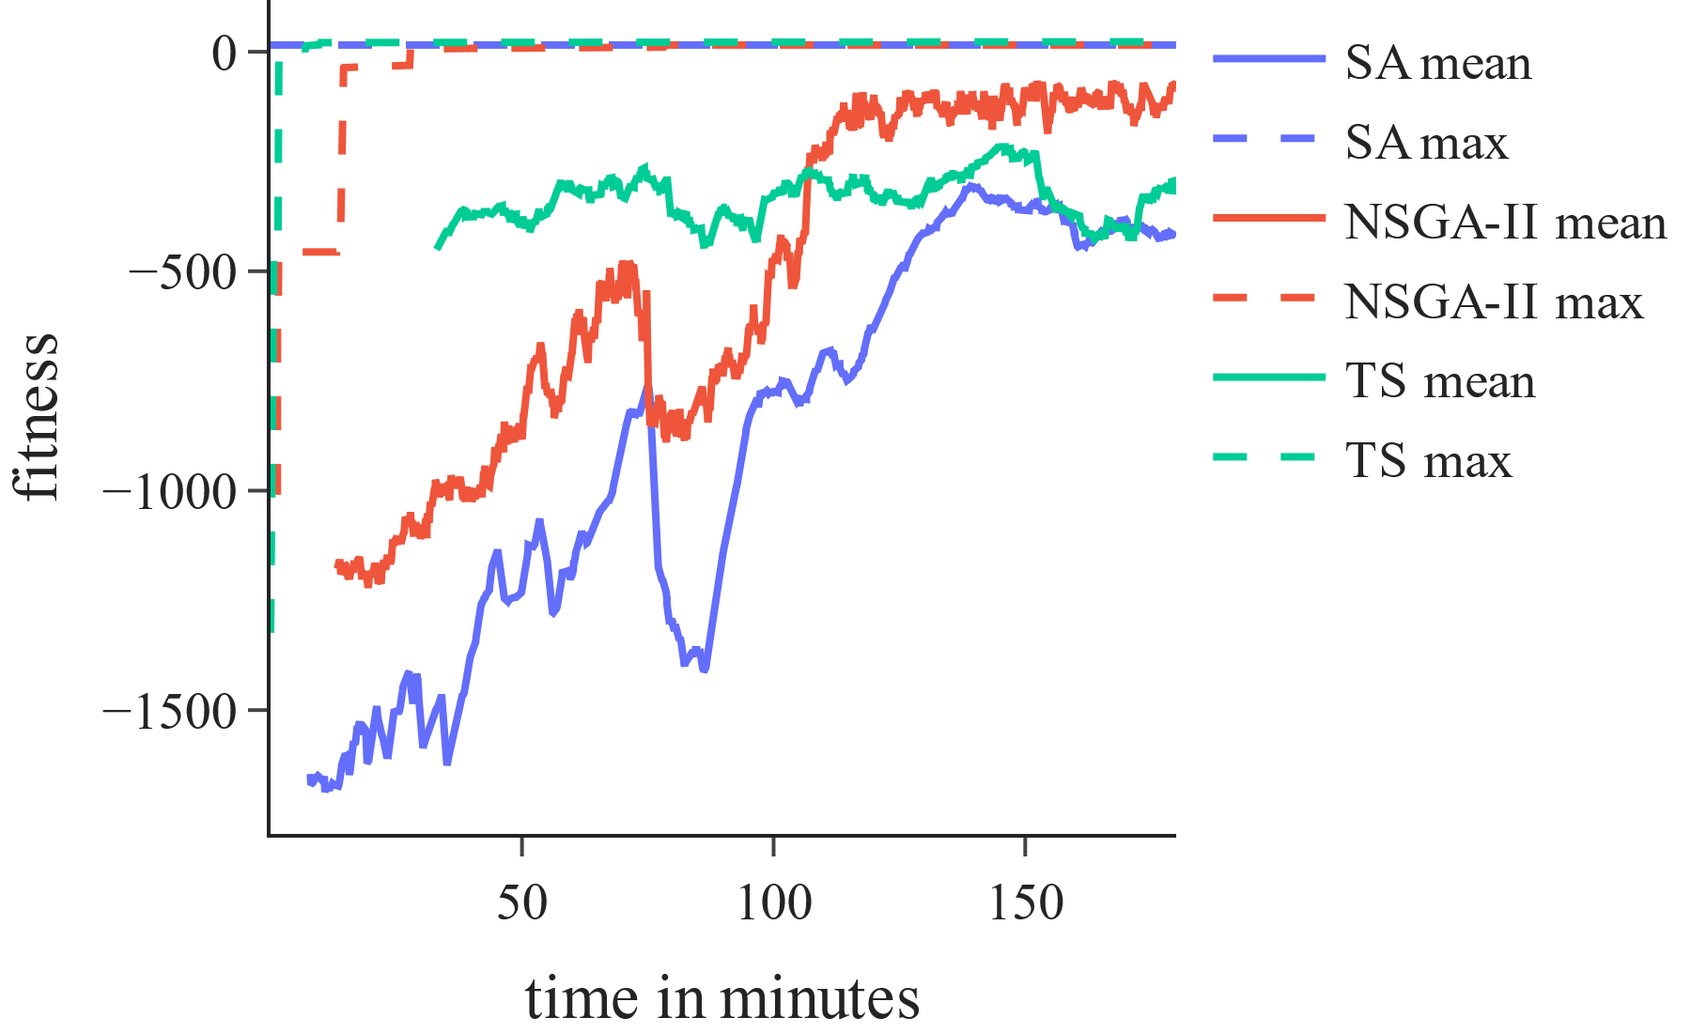 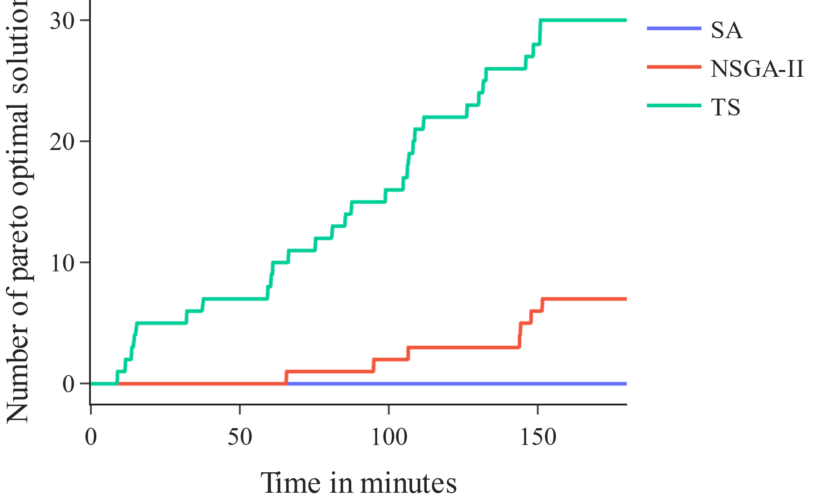

Figure 1: Maximum and rolling average performance of the three meta heuristics over time (left) and number of found pareto-optimal solutions per meta heuristic over time (right)

In the left diagram of Figure 1, the max and rolling average of the fitness of the three heuristics over optimization time is displayed. All three algorithms manage to improve their best fitness over time and NSGA-II and SA improve their average dramatically. It is also visible that all algorithms reach a steady fitness level, where TS reaches this steady state very early. When comparing the rolling average fitness, NSGA-II reaches a higher fitness than SA and TS.

The right diagram of Figure 1 shows the number of found pareto-optimal solutions for the three algorithms over time. As the combinatorial complexity of the benchmark use case is too big to evaluate all possible configurations, the pareto-optimal solutions are only derived from all evaluated configurations of the three optimization runs. The diagram indicates that SA finds no pareto-optimal solution and TS finds much more pareto-optimal solutions than NSGA-II. Similarly, to the left diagram of Figure 1, TS finds good solutions fast when compared to SA and NSGA-II. Although TS is based on fitness optimization and NSGA-II on multi-objective optimization, TS finds more pareto-optimal solutions and NSGA-II has a higher average fitness.

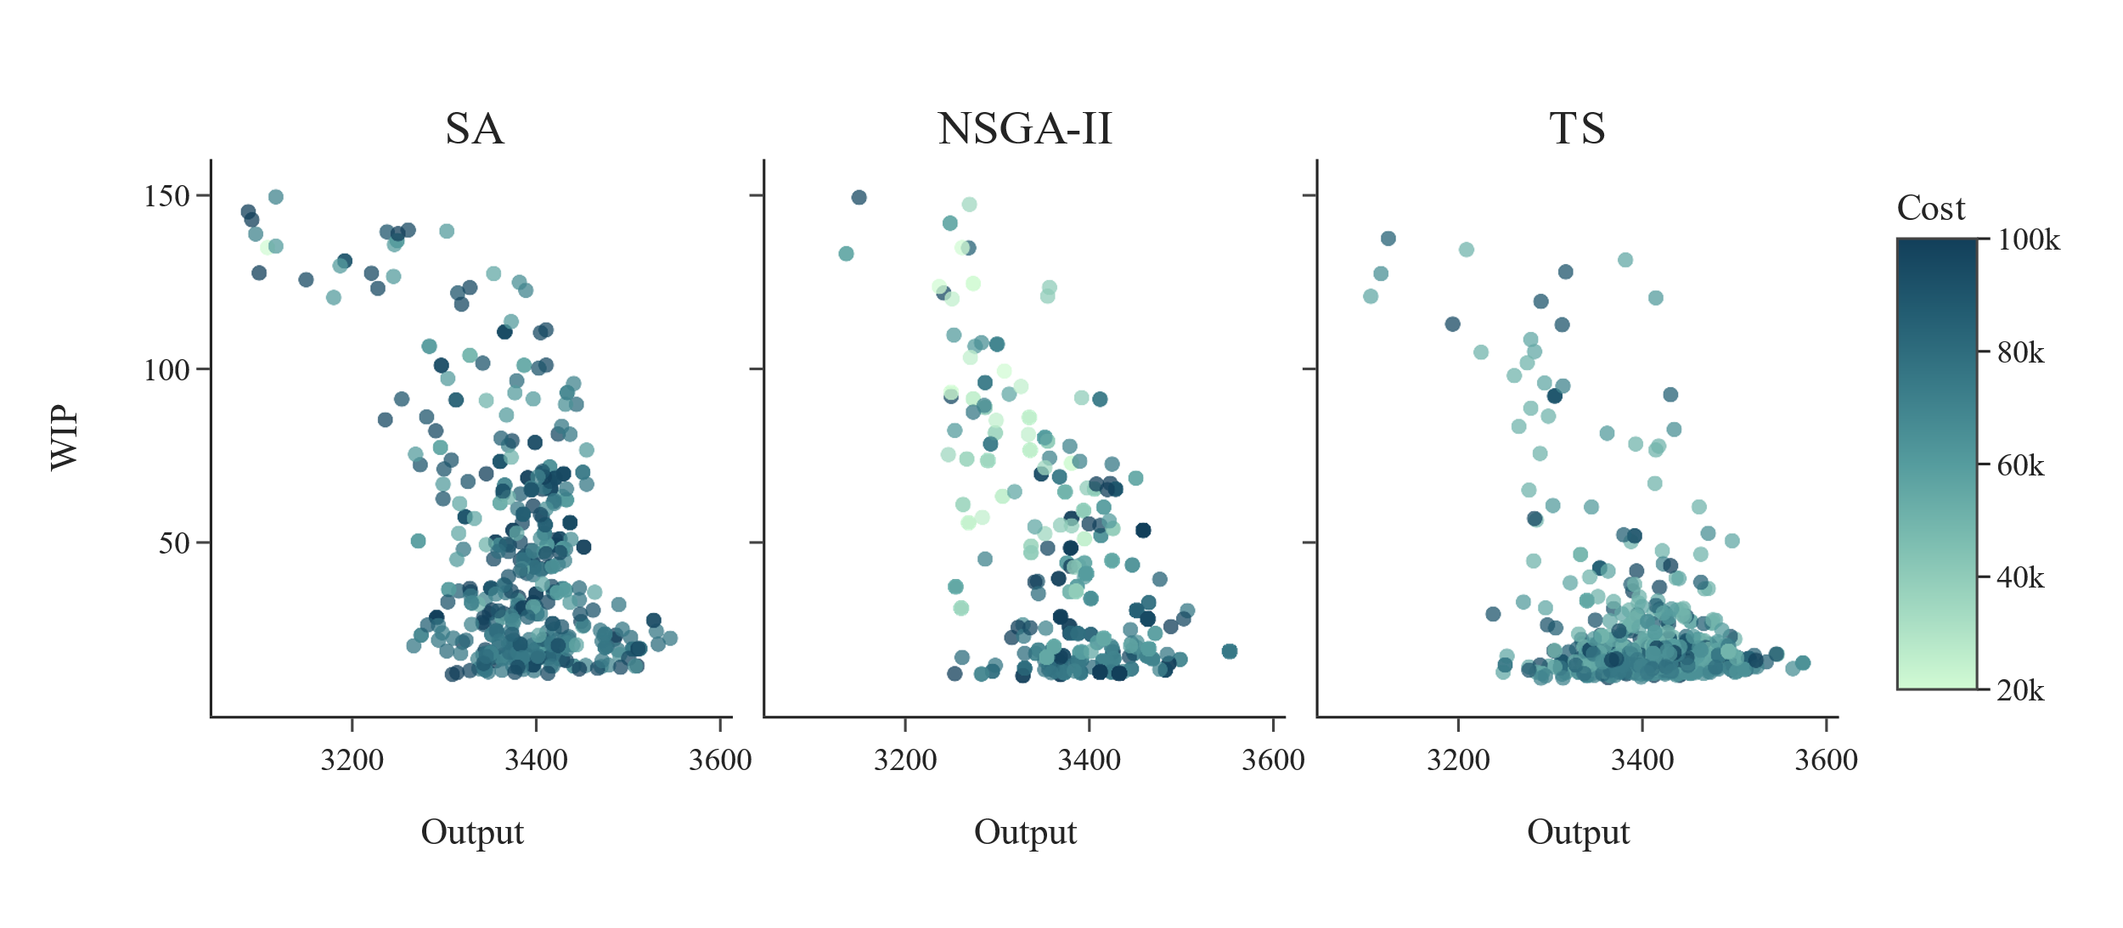

Figure 2: Throughput, inventory and cost distribution of found configurations per meta heuristic in the interesting region.

As the reconfiguration problem is a multi-objective optimization problem, we want to consider how the found configurations are distributed in the earlier defined interesting region. Figure 2 shows this by displaying the three objectives cost (colouring), throughput and inventory for the analysed three meta heuristics. It is visible that NSGA-II and SA has a very broad distribution of found configurations in the interesting region but especially solutions of SA with high inventory are in average costlier than the ones found by NSGA-II and TS. Contrastingly, TS has the narrowest search, focusing heavily and low inventory, medium cost configurations.

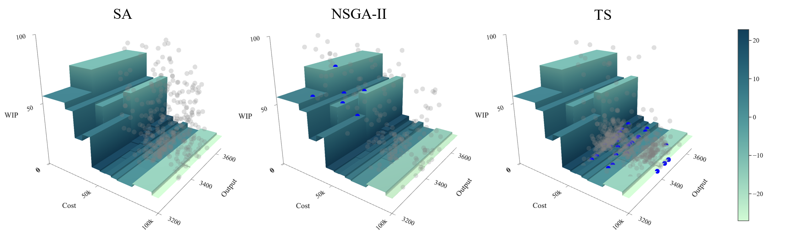

Figure 3: Output, inventory and cost distribution of found configurations per meta heuristic in the interesting region with an interpolation of the pareto-front and display of pareto-optimal points.

In order to evaluate, where the pareto-optimal configurations are found in the search space per algorithm, Figure 3 can be regarded. The three diagrams show 3D plots of the three objectives cost, throughput and inventory where all configurations of the interesting region are displayed in grey and pareto-optimal solutions are displayed in blue. The pareto-front is thereby displayed as an interpolated surface with a colour according to the fitness. The pareto-front can be divided into two distinct regions: high cost with low inventory (I) and low inventory with high cost (II). Interestingly, the pareto-optimal solutions of region I are exclusively found by NSGA-II and the solutions of region II exclusively by TS. It is visible that the configurations found by TS have a very high focus in the region with high fitness values whereas configurations found by NSGA-II are much broader distributed. This can be explained by the fact, that TS optimizes fitness whereas NSGA-II optimizes all objectives. The fact that NSGA-II finds no pareto-optimal solutions in region II is due to the fact that TS exploits this region more strongly and finds their better solutions. The previous observation that TS finds more pareto-optimal solutions but has a lower average fitness compared to NSGA-II can be explained by two facts. At first, the pareto-optimal solutions are much more densely packed in region II than in region I as TS searched this region very exhaustively. Secondly, the selection method of NSGA-II leads to redundant but good solutions in a population which explains the high average fitness.

In summary, TS and NSGA-II show a better performance in optimization than SA while SA showed to be much more instable and hyperparameter sensitive. This limits the use of SA for practical applications. TS and NSGA-II exhibit a good performance for different objectives. If a multi-objective search space of an RMS has to be evaluated, NSGA-II is more suited. Contrarily, if a designated operating point considering the objectives is given, TS shows a better behaviour. As combinatorial complexity increases strongly with the size of the RMS, fast optimization gets more important. This motivates again the use of TS. Future research should examine how this approach is applicable to larger problem settings. However, as TS is not as easily parallelizable as population-based optimization methods, the potential of parallelization and combination of TS with a population-based method should be evaluated. Lastly, future research could evaluate how this approach can be extended with more degrees of freedom in order to represent a more generalizable production planning approach.

1. Conclusion

The paper at hand evaluates the capability of the meta-heuristics SA, TS and NSGA-II for the optimization of a RMS. After reviewing state-of-the-art literature from the domain of RMS optimization, it is motivated that recent approaches either lack high model accuracy and detail or many degrees of freedom considering the reconfigurations. Therefore, we formulate an optimization problem description of an RMS that considers structural as well as logical changes on the machine and system level. To evaluate the capability of SA, TS and NSGA-II optimization experiments are performed with use of discrete-event simulation as evaluation model. The results indicate that all meta-heuristics are able to find good configurations of the RMS in a defined amount of time. However, SA shows an inferior performance than TS and NSGA-II. As a conclusion, the approach demonstrates that reconfiguration planning of RMS is possible to automate by simulation-based optimization with only little need for manual meta-heuristic configuration. These insights motivate to conduct further research that assesses how this approach is applicable to larger problem settings, how parallelization can be used to reduce optimization time and how the degrees of freedom of the RMS could be extended to a broader, more general production planning approach.

**Acknowledgements**

We extend our sincere thanks to the German Federal Ministry for Economic Affairs and Climate Action (BMWK) for supporting this research project 13IK001ZF “Software-Defined Manufacturing for the automotive and supplying industry https://www.sdm4fzi.de/”.

**References**

[1] Koren, Y., Heisel, U., Jovane, F., Moriwaki, T., Pritschow, G., Ulsoy, G., van Brussel, H., 1999. Reconfigurable Manufacturing Systems. CIRP Annals 48 (2), 527–540.

[2] Mehrabi, M.G., Ulsoy, A.G., Koren, Y., Heytler, P., 2002. Trends and perspectives in flexible and reconfigurable manufacturing systems. Journal of Intelligent Manufacturing 13 (2), 135–146.

[3] ElMaraghy, H.A., 2006. Flexible and reconfigurable manufacturing systems paradigms. International Journal of Flexible Manufacturing Systems 17 (4), 261–276.

[4] Mack, O., Khare, A., Krämer, A., Burgartz, T. (Eds.), 2016. Managing in a VUCA world. Springer, Cham, Heidelberg, New York, Dordrecht, London, 259 pp.

[5] Lanza, G., Asfour, T., Beyerer, J., Deml, B., Fleischer, J., Heizmann, M., Furmans, K., Hofmann, C., Cebulla, A., Dreher, C., Kaiser, J.-P., Klein, J.-F., Leven, F., Mangold, S., Mitschke, N., Stricker, N., Pfrommer, J., Wu, C., Wurster, M., Zaremski, M., 2022. Agiles Produktionssystem mittels lernender Roboter bei ungewissen Produktzuständen am Beispiel der Anlasser-Demontage. at - Automatisierungstechnik 70 (6), 504–516.

[6] Wurster, M., Häfner, B., Gauder, D., Stricker, N., Lanza, G., 2021. Fluid Automation — A Definition and an Application in Remanufacturing Production Systems. Procedia CIRP 97, 508–513.

[7] Wiendahl, H.-P., ElMaraghy, H.A., Nyhuis, P., Zäh, M.F., Wiendahl, H.-H., Duffie, N., Brieke, M., 2007. Changeable Manufacturing - Classification, Design and Operation. CIRP Annals 56 (2), 783–809.

[8] Wiendahl, H.-P., Reichardt, J., Nyhuis, P., 2014. Handbuch Fabrikplanung: Konzept, Gestaltung und Umsetzung wandlungsfähiger Produktionsstätten, 2., überarb. und erw. Aufl., [elektronische Ressource] ed. Hanser Verlag, München.

[9] Oluyisola, O.E., Sgarbossa, F., Strandhagen, J.O., 2020. Smart Production Planning and Control: Concept, Use-Cases and Sustainability Implications. Sustainability 12 (9), 3791.

[10] Tempelmeier, H., 2003. Practical considerations in the optimization of flow production systems. International Journal of Production Research 41 (1), 149–170.

[11] Uribe, A.M., Cochran, J.K., Shunk, D.L., 2003. Two-stage simulation optimization for agile manufacturing capacity planning. International Journal of Production Research 41 (6), 1181–1197.

[12] Youssef, A.M.A., ElMaraghy, H.A., 2007. Optimal configuration selection for Reconfigurable Manufacturing Systems. Int J Flex Manuf Syst 19 (2), 67–106.

[13] Stähr, T., Englisch, L., Lanza, G., 2018. Creation of configurations for an assembly system with a scalable level of automation. Procedia CIRP 76 (9), 7–12.

[14] Sabioni, R.C., Daaboul, J., Le Duigou, J., 2021. Optimization of Reconfigurable Manufacturing Systems Configuration: A Literature Review, in: Roucoules, L., Paredes, M., Eynard, B., Morer Camo, P., Rizzi, C. (Eds.), Advances on Mechanics, Design Engineering and Manufacturing III, vol. 48. Springer International Publishing, Cham, pp. 426–435.

[15] M. Vorderer, S. Junker, A. Lechler, A. Verl, 2016. CESA3R: Highly versatile plug-and-produce assembly system, in: 2016 IEEE International Conference on Automation Science and Engineering (CASE). 2016 IEEE International Conference on Automation Science and Engineering (CASE), pp. 745–750.

[16] Kritzinger, W., Karner, M., Traar, G., Henjes, J., Sihn, W., 2018. Digital Twin in manufacturing: A categorical literature review and classification. IFAC-PapersOnLine 51 (11), 1016–1022.

[17] Smith, J.S., Wysk, R.A., Sturrock, D.T., Ramaswamy, S.E., Smith, G.D., Joshi, S.B., 1994. Discrete event simulation for shop floor control, in: 1994 Winter Simulation Conference proceedings. Lake Buena Vista, Florida, December 11 - 14, 1994. Winter Simulation Conference, Lake Buena Vista, FL, USA. 11-14 Dec. 1994. Assoc. for Computing Machinery, New York, NY, pp. 962–969.

[18] Turner, C.J., Hutabarat, W., Oyekan, J., Tiwari, A., 2016. Discrete Event Simulation and Virtual Reality Use in Industry: New Opportunities and Future Trends. IEEE Trans. Human-Mach. Syst. 46 (6), 882–894.

[19] Valet, A., Altenmüller, T., Waschneck, B., May, M.C., Kuhnle, A., Lanza, G., 2022. Opportunistic maintenance scheduling with deep reinforcement learning. Journal of Manufacturing Systems 64, 518–534.

[20] Spedding, T.A., Sun, G.Q., 1999. Application of discrete event simulation to the activity based costing of manufacturing systems. International Journal of Production Economics 58 (3), 289–301.

[21] Kohl, J., Spreng, S., Franke, J., 2014. Discrete Event Simulation of Individual Energy Consumption for Product-varieties. Procedia CIRP 17, 517–522.

[22] Gansterer, M., Almeder, C., Hartl, R.F., 2014. Simulation-based optimization methods for setting production planning parameters. International Journal of Production Economics 151, 206–213.

[23] Law, A.M., McComas, M.G., 2002. Simulation-based optimization, in: Exploring new frontiers. 2002 Winter Simulation Conference, San Diego, CA, USA. 8-11 Dec. 2002. IEEE, pp. 41–44.

[24] Chaudhry, I.A., Khan, A.A., 2016. A research survey: review of flexible job shop scheduling techniques. Intl. Trans. in Op. Res. 23 (3), 551–591.

[25] Little, J.D.C., Graves, S.C., 2008. Little's Law, in: , Building Intuition. Springer, Boston, MA, pp. 81–100.

[26] Pinedo, M.L., 2012. Scheduling. Springer US, Boston, MA.

[27] Ahmed, Z.E., Saeed, R.A., Mukherjee, A., Ghorpade, S.N., 2020. Energy optimization in low-power wide area networks by using heuristic techniques, in: , LPWAN technologies for IoT and M2M applications; Ed. by Bharat S. Chaudhari. Elsevier Academic Press, London, pp. 199–223.

[28] Deb, K., Pratap, A., Agarwal, S., Meyarivan, T., 2002. A fast and elitist multiobjective genetic algorithm: NSGA-II. IEEE Trans. Evol. Computat. 6 (2), 182–197.

[29] Zhan, S., Lin, J., Zhang, Z., Zhong, Y., 2016. List-Based Simulated Annealing Algorithm for Traveling Salesman Problem. Computational Intelligence and Neuroscience 2016 (5), 1712630.

[30] Glover, F., 1990. Tabu Search: A Tutorial. Interfaces 20 (4), 74–94.

**Biography**

**Sebastian Behrendt** (*1997) is a research associate at the Institute of Production Science (wbk) at the Karlsruhe Institute of Technology (KIT) and works in the group of production system planning. He studied mechanical engineering with a specialization in production systems, data analysis and machine learning at the Karlsruhe Institute of Technology (KIT).

**Marco Wurster** (*1993) is a research associate at the Institute of Production Science (wbk) at the Karlsruhe Institute of Technology (KIT) working in the group of production system planning. In his research he focuses on production planning and control of agile production systems in environments with a high degree of uncertainty such as remanufacturing and product disassembly.



**Marvin Carl May** (*1994) is a researcher at the Institute for Production Science (wbk) at the Karlsruhe Institute of Technology (KIT). His research concerns production system optimisation on strategical, tactical and operational levels by means of intelligent algorithms. The focus lies on discrete manufacturing, in close cooperation with industry, e.g. semiconductor manufacturing, and aims at researching and implementing innovative and application-oriented solutions to technological problems.

**Gisela Lanza** (*1973) is member of the management board at the Institute of Production Science (wbk) of the Karlsruhe Institute of Technology (KIT). She heads the Production Systems division dealing with the topics of global production strategies, production system planning, and quality assurance in research and industrial practice. Her research focus is on the holistic design and evaluation of production systems. The methodological approach includes the use of quantitative methods to increase efficiency. In addition, a special focus is placed on data-driven planning and control of production networks in   
order to translate corporate strategy into tactical and operative network design.